https://www.bezkoder.com/spring-boot-redis-cache-example/

Without redis – testing foe 20 threads (get , put , post , delete)
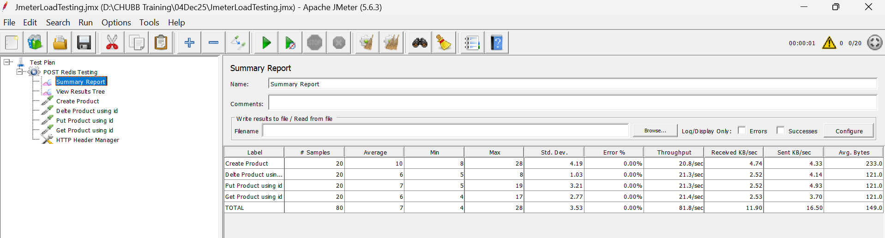

With Redis
